

National University Of Computer and Emerging

Sciences



Islamic Economy Simulation

Syed Dilawar Ali Rizvi

Supervisor: Farooq Ahmad

B.S. Computer Science

Final Year Project: January 2012

Department of Computer Science

FAST NU, Lahore, Pakistan

Anti-Plagiarism Declaration

This is to declare that the above publication produced under the:

**title: Islamic Economy Simulation (IES)**

is the sole contribution of the author(s) and no part hereof has been reproduced on **as it is** basis (cut and paste) which can be considered as **Plagiarism.** All referenced parts have been used to argue the idea and have been cited properly. I/We will be responsible and liable for any consequence if violation of this declaration is determined.

Date: Dec 15, 2012

Name: Syed Dilawar Ali Rizvi

Signature: ___________________

Name: Haider Ali

Signature: ___________________

Name: Ozair Shafiq

Signature: ___________________

Name: Umair Baig

Signature: ___________________

Table of Contents

Contents

Anti-Plagiarism Declaration 2

Table of Contents 3

1. 1. Introduction 6

2. Goals and objectives 7

2.1 Make the game interesting enough 7

2.2 Attract enough players to register 7

2.3 Ensure user satisfaction 7

2.4 Game should be self-sustainable 7

2.5 Enactment of Islamic Principles 7

2.6 Deduce Economic Evaluations 7

3. Scope of the project 8

3.1 Farmer 8

3.2 Bait ul Maal 8

3.3 Seeds 8

3.4 Food 8

3.5 Super Market 8

3.5.1 Price Calculation in Super Market 8

4. System Requirements 10

4.1 Functional Requirement 10

4.1.1 Farm 10

4.1.2 Shop 10

4.1.3 Bait ulMaal 11

4.1.4 System 11

4.2 Non-Functional Requirements 12

4.3 Hardware and Software Requirements 12

4.3.1 Hardware Requirements 12

4.3.2 Software Requirements 12

5. Detailed Design and Architecture 13

5.1 Component level Design 13

5.2 Use case diagram 14

5.3 Database model 15

5.4 Communication between different components 16

6. GUIs 17

6.1 Sign in 17

6.2 Main view 17

6.3 Market 18

6.4 Charity bar 18

7. API Documentation 19

7.1 Login 20

7.2 Sign up 21

7.3 User credentials 22

7.4 Alter Farm State 23

7.5 Create Farm 23

7.6 Create Farm 24

7.7 Farm Information 25

7.8 Update score 26

7.9 Update energy 27

7.10 Update Coin 28

7.11 Save Transaction 29

7.12 Get rates 30

8. To do list 31

8.1 List of functionalities still to implement 31

9. Bug Report 32

10. References 33

**List of Figures**

Figure 3‑1 9

Figure 3‑2 9

Figure 5‑1 13

Figure 5‑2 14

Figure 5‑3 15

Figure 5‑4 16

Figure 6‑1 18

Figure 7‑1 19

Figure 7‑2 19

Figure 7‑3 20

Figure 7‑4 20

Abstract

Occupy Wall Street movement started on September 17th 2011 in response to an ad in the 97th issue of a Canadian magazine called Ad busters. The advertisement was motivated by the public uprisings in Middle Eastern countries, particularly those of Egypt where Tahrir square in Cairo became the center of the uprising. The people behind this movement wanted to replicate Tahrir square in Manhattan, NY. Detailed history of the movement is beyond the scope of this document, but can be found at nadeemchaudhry.blogspot.com.These people have realized that the root cause of economic disparity is the capitalistic system and it is not working for them. In fact it is working against them. It is causing the wealth to flow from poor to rich. They want an alternate economic system but when asked about this alternative economic system, the answer is silence because they either don’t have any idea about the alternative or that there is no current example of their proposed idea.We believe that Islamic economic system is the alternative system but the problem arises with the fact that there is no concrete to step upon at the present because there is no current state that has this system incorporated in its economic system which drove us to the conclusion that in such a situation a simulation in the virtual world could prove fruitful and hence provoked us to initiate this project.

# 1. Introduction

Occupy Wall Street movement started on September 17th 2011 in response to an ad in the 97th issue of a Canadian magazine called Ad busters. The advertisement was motivated by the public uprisings in Middle Eastern countries, particularly those of Egypt where Tahrir square in Cairo became the center of the uprising. The people behind this movement wanted to replicate Tahrir square in Manhattan, NY. Detailed history of the movement is beyond the scope of this document, but can be found at nadeemchaudhry.blogspot.com.

The primary motivating factor of the movement is the huge economic disparity between the majority of people and an elite group of extremely wealthy people. The people in this movement make the point that 1% of the population is hoarding resources while the remaining 99% of the population is being deprived and they represent the 99%.

This charge is fully backed by published data. In 1983 the top 1% of the population owned 33.8% of the wealth while the bottom 80% owned 18.7%. This lopsided distribution has become even worse. In 2007 the share of wealth of the top 1% increased to 34.6% while that of the bottom 80% dropped to 15%.

The idea behind this work is to simulate an economy system with real time players, real time hurdles of natural disaster, and an economy generation motive i.e. user profiles would logged and scored depending on their respective throughput of crop generation or marketing products (both of these terms would be explicitly explained when the functional requirements would be discussed), and behavior of the player with other interacting players. The main scoring criteria is not to only increase wealth but also incentives are to be considered and features such as affection and kindness are held as a high merit.

The present conditions of time constraints and man power have provoked us to conclude the fact that the number of occupation entities in the game need to be restricted at two i.e. Farm and Super Market. The will be given a suitable amount of resources at the registration time and will be given a choice to select one of the two occupations from which point on the game would continue according to the effort and determination of the player.

The two occupations discussed above have an interdependency of give and take i.e. trade of goods between different players belonging to different occupations and hence a fraction of the country’s economy would be simulated.

After enough players have been registered in the game and a cycle of give and take has been established then another feature of the system i.e. the Expert Engine would come into action to verify whether a stable economy is being generated by observing the Islamic Laws incorporated into the system. The results of the Expert Engine would determine the fact that whether the Islamic Economy System is a suitable alternative for the current capital economic system.

# Goals and objectives

The main goal of this project is to develop an economy simulation with the idea that people will participate in this game and during their game play they would replicate the economic cycle of a country. Hence the following goals and objectives can be drawn from the above specification:

## Make the game interesting enough

The game needs to be intriguing and interesting enough so that the players will participate in this game willingly and in an unaware fashion that this game is basically an experiment to observe an alternating economic system compared to the present capitalistic economic system.

## Attract enough players to register

Until and unless a reasonable amount of players register in this game play, a reasonable statistical conclusion cannot be drawn due to which provoking enough players to register would of high priority.

## Ensure user satisfaction

The user needs to be satisfied with the game displays and maneuverability so that the user does continue playing the game.

## Game should be self-sustainable

Once the game has been aired on the server the game should self-sustain itself i.e. the bait ul maal will take on the overhead of resource distribution between the new players.

## Enactment of Islamic Principles

The system should force the enactment of Islamic Principles so that every economic action is taken according to the rules defined in the system.

## Deduce Economic Evaluations

The Expert Engine incorporated in the system would draw out statistical analysis of the economy in the game and would deduce results regarding the stability of the economy, this is probably the most important goal and objective of this development cycle as the results converge to a stable value and henceforth a result is drawn then we could either approve or reject the applicability of our alternative economic system.

# Scope of the project

## Farmer

A mean of earning in the game, players will work on the farm like a farmer and earn credit by producing and trading crops

## Bait ul Maal

This is probably the most important entity of the system as this is the main sustainer of the economy because it caters the tasks of resource allocation, charity distribution, charity collection, zakat collection and zakat distribution

## Seeds

Seeds are required for farms and available at shops, seeds would be of different type and different quality

## Food

Food is a basic and essential resource for players, the type and amount of the food will determine the level of energy of the player, and the energy of the player is directly related to the performance of the player i.e. the energy required to perform a particular task

## Super Market

The Super Market entity contains the different features which reflect the model real time Super Market.

* A super market maintains a list of product items along with their prices
* Consumers may come to the store and chose items of their choice and purchase them

### Price Calculation in Super Market

Rates in market are calculated on the basis of demand and supply of previous 2 days. Total request to buy a product is considered as demand and total request to sell a product in the market is considered as supply to the market. To generate next day price we need to take rates, supply and demand of last two days. Linear equation is constructed for supply and another linear equation is constructed for demand. Equating both linear equations give we fair price for the next day.

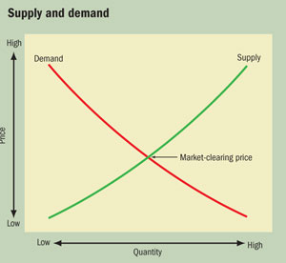

Figure ‑

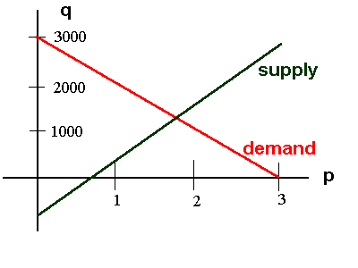

Figure ‑

# System Requirements

## Functional Requirement

The functional requirements have been divided into categories according to their entity classification and are listed below:

### Farm

1. Player must be able to create farm
2. Player must be able to seed farm with different seeding options (wheat, corn)
3. Player must be able to irrigate and fertilize farm
4. Player must be able to cultivate the farm (a visual animation of player while cultivating farm would be show on the main scene)
5. Player can buy seed and fertilizer
6. Player could hire virtual players
7. Player could buy virtual machinery
8. Farm owners could sell their property
9. farm owner can update farm info
10. only farm owner of the farm can sell the farm
11. only farm owner can update the farm info (price)
12. Farm Owner could sell his product to the super market

### Shop

1. Player can view a list of products in any shop
2. Player can buy any product from the owner of that shop
3. Shop owners can list the prices of the products that they have in their shop
4. Player can buy food from shop
5. only shop owner can sell the shop
6. only shop owner can set the price of the shop
7. Shop owners could buy products from the super market
8. Players can make request of zakat from Bait ulMaal

### Bait ulMaal

1. Bait ul Maal should be able to collect zakat from players
2. Bait ul Maal should be able to distribute zakat to players
3. Bait ul Maal should be able to collect charity from players
4. Bait ul Maal should be able to distributecharityto players
5. Bait ul Maal should be able to allocate resources to the players

### System

1. System should control the weather of the city
2. System should display energy level of players on their main screen
3. System should manage transport system of the city
4. System should provide a mean of limited chatting among players (so that players can take load from each other)
5. System should able to create natural disasters randomly
6. System could reboot the economy of the city
7. Player could buy any property
8. Players can chat with one and each other for loan just using finite set of phrases provided by the system
9. System should ensure that a player cannot sale his property below what was given to him initially by Bait ul Maal

## Non-Functional Requirements

1) User interface should be simple and easy to learn, easy to use

2) Menu’s should be simple and should be of at max 3 navigations.

## Hardware and Software Requirements

### Hardware Requirements

The minimum requirement for this game to run could simply be any ordinary PC but for this game to run efficiently it is recommended that the computer must be a Pentium 4 or equivalent technology.

### Software Requirements

The software requirement for this game to run requires a web browser of latest release such as Opera version 10.0, IE 10 or equivalent with an additional software i.e. adobe flash player.

# Detailed Design and Architecture

## Component level Design

Figure 5.1 specifies the component level design of the system, which includes the main components of player, farm, shop, bait ul maal and expert engine. The interaction between the components of player and the components of farm and shop are controlled by the component of access controlled list.

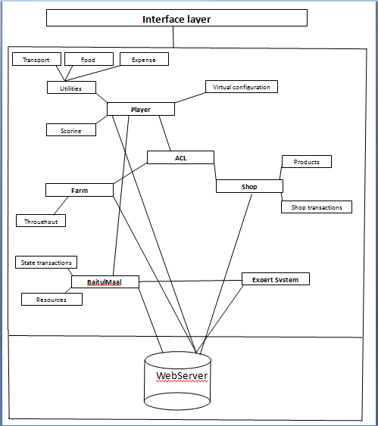

Figure ‑

## Use case diagram

The following figure exemplifies the actors and there use cases for interacting with the system, the detailed description of which is presented in the requirement specification document.

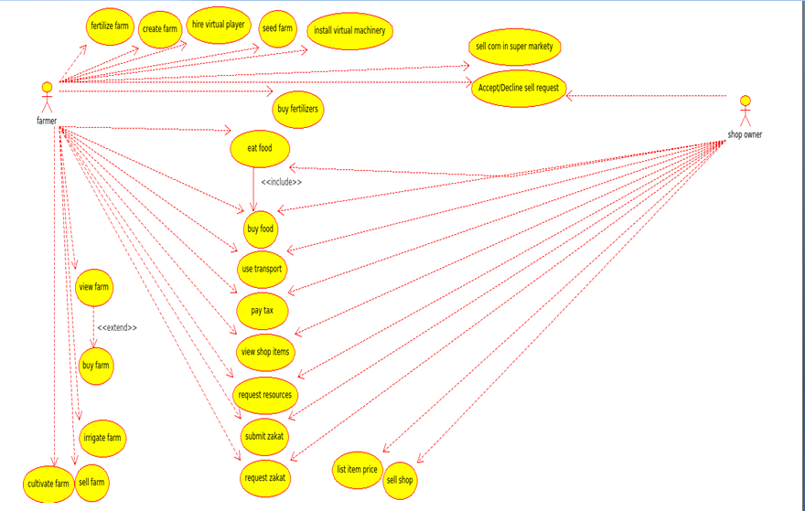

Figure ‑

## Database model

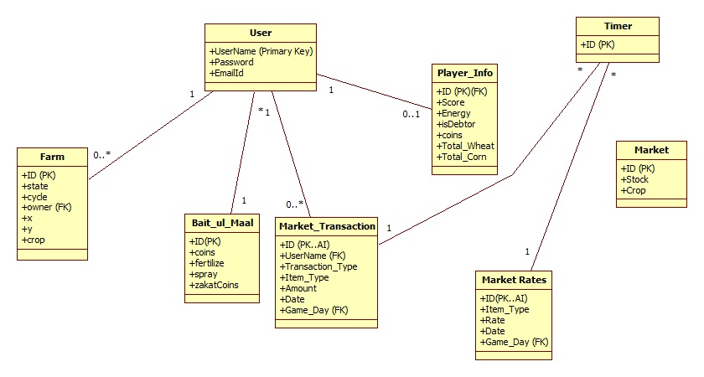

Figure ‑

## Communication between different components

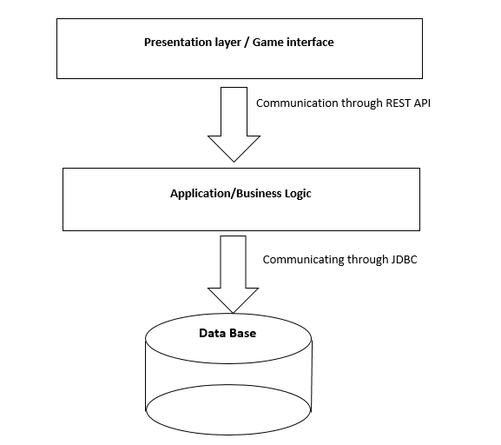

Figure ‑

Figure ‑

# GUIs

## Sign in

Figure ‑

## Main view

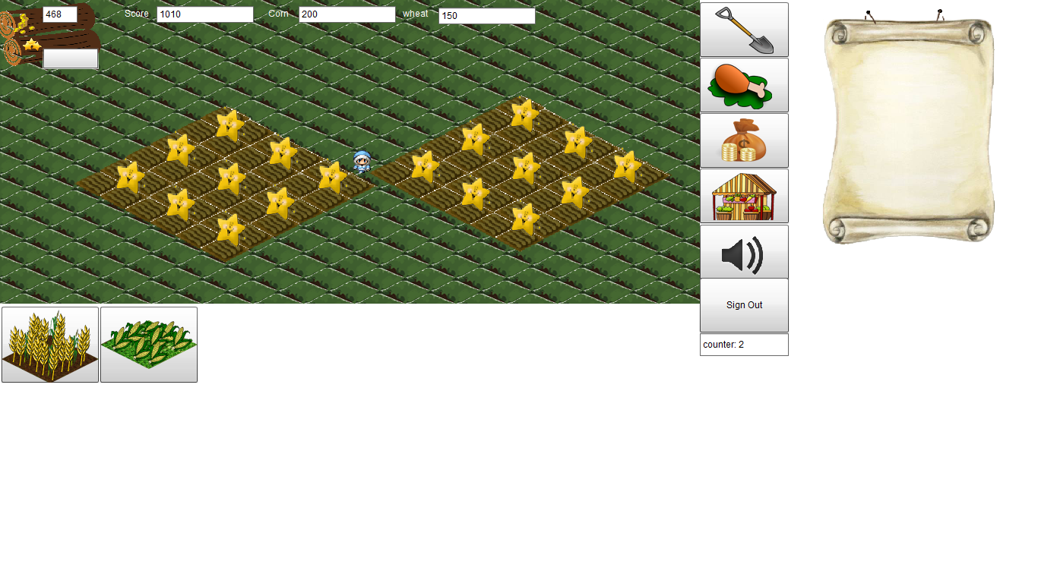

Figure ‑

## Market

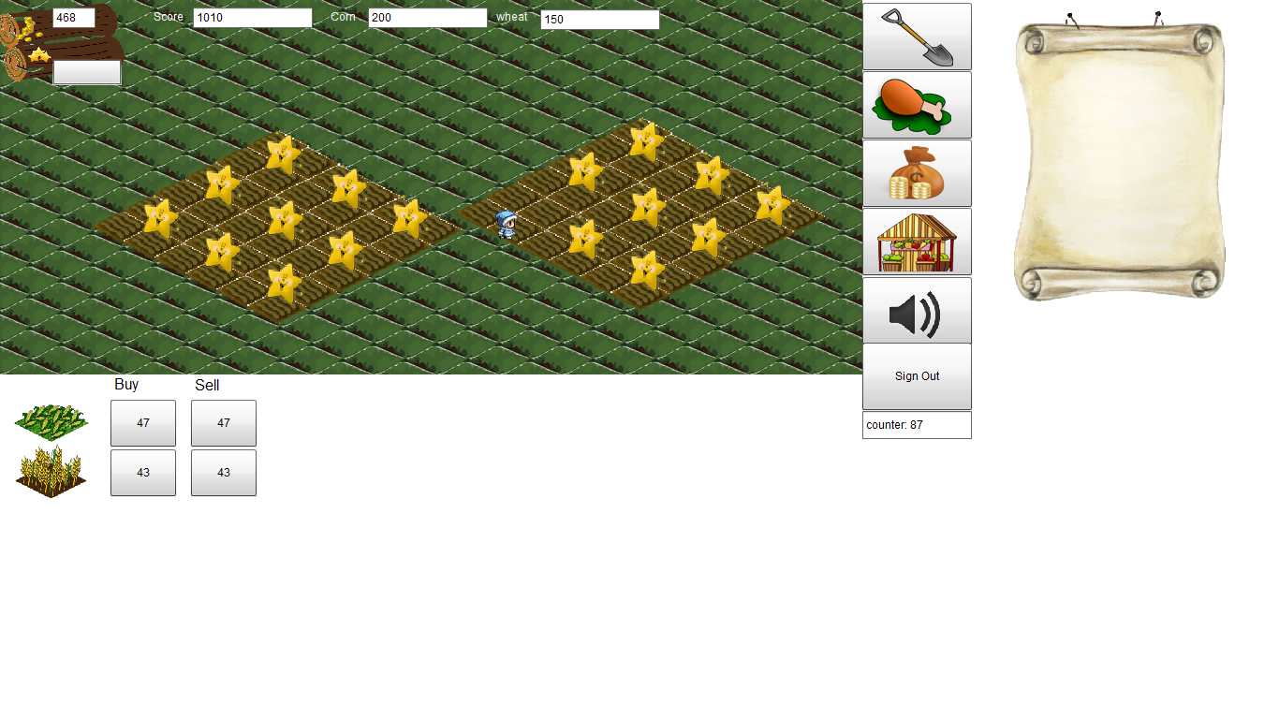

Figure ‑

## Charity bar

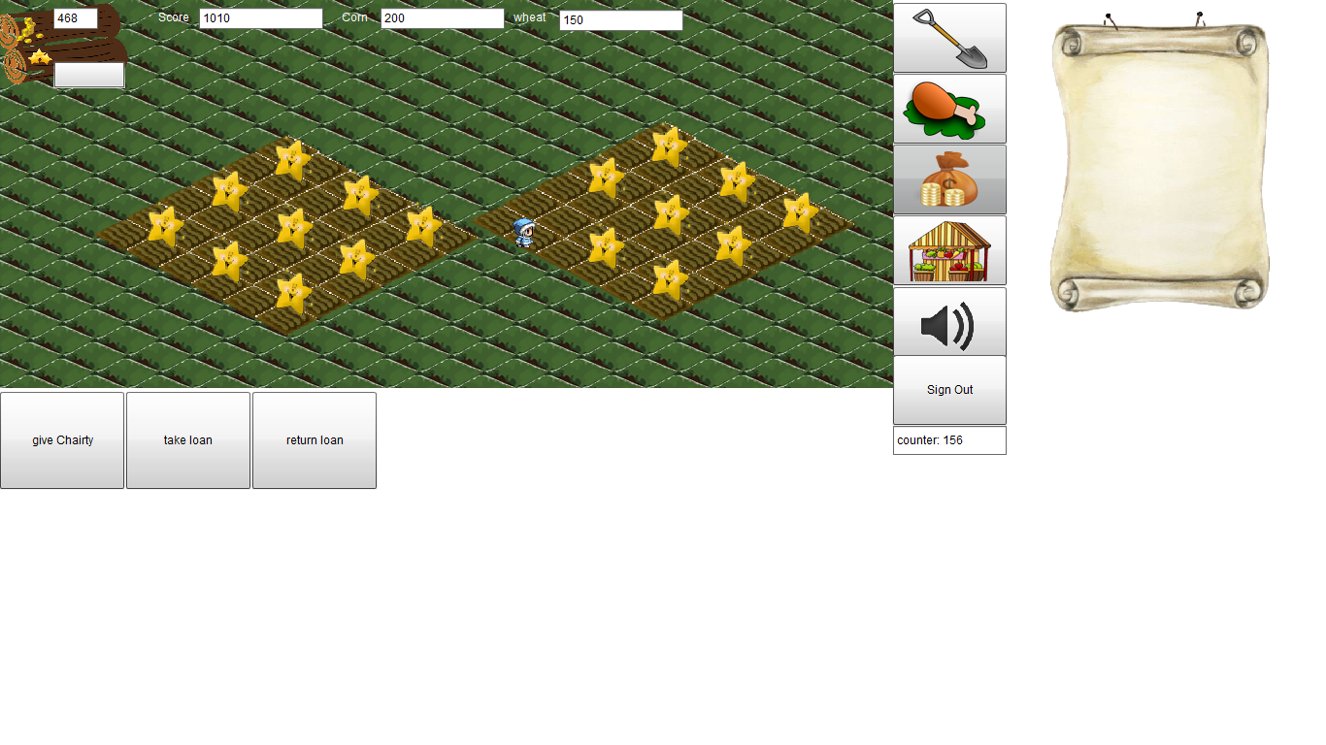

Figure ‑

# API Documentation

Rest API’s are used for the data communication between client and server. URL of API consist of Hostname, servlet name, action and list of parameters. For example for login API the uri is

<http://localhost:8080/WebApplication3/user?action=login&username=ali&password=123>

|  |  |
| --- | --- |
| Host Name | http://localhost/WebApplication3 |
| Port # | 8080 |
| Servlet | user |
| Action | login |
| Parameter1 | Username=ali |
| Parameter2 | Password=123 |

**Note: each URL map to a servlet’s function through doGet function**

Each API request returns an xml with label data. For example API for retrieving user information might look like this

Here is given complete list of API’s

## Login

|  |  |
| --- | --- |
| Purpose | For user login purpose |
| URL | http://localhost:8080/WebApplication3/user?action=login |
| Type | GET |
| parameters | username  password |
| Response | Response will be an xml contain a true/false value within a single root element indicating login successful or not respectively. |

## Sign up

|  |  |
| --- | --- |
| Purpose | For user sign up purpose |
| URL | http://localhost:8080/WebApplication3/user?action=signUp |
| Type | GET |
| Parameters | Username  Password  Email |
| Response | Response will be an xml contain a true/false value within a single root element indicating sign up successful or not respectively. |

## User credentials

|  |  |
| --- | --- |
| Purpose | To get users state (i.e. coins, score, total wheat, energy ….etc) |
| URL | http://localhost:8080/WebApplication3/user?action=init |
| Type | Get |
| Parameters | username |
| Complete URL | http://localhost:8080/WebApplication3/user?action=init&username=ali |
| response | Response will contain an xml contains difference tags having corresponding values |

## Alter Farm State

|  |  |
| --- | --- |
| Purpose | To change the state of the farm |
| URL | http://localhost:8080/WebApplication3/farm?action=alterFarmState |
| Type | GET |
| Parameters | ID  state |
| Complete URL | http://localhost:8080/WebApplication3/farm?action=alterFarmState&ID=87&state=3 |
| Response | No response API will update the state of the farm if parameters are write |

## Create Farm

|  |  |
| --- | --- |
| Purpose | To get users state (i.e. coins, score, total wheat, energy ….etc) |
| URL | http://localhost:8080/WebApplication3/user?action=init |
| Type | GET |
| Parameters | username |
| Complete URL | http://localhost:8080/WebApplication3/farm?action=alterFarmState&ID=87&state=3 |
| Response | No response API will update the state of the farm if parameters are write |
|  |  |
|  |  |

## Create Farm

|  |  |
| --- | --- |
| Purpose | To create new farm |
| URL | <http://localhost:8080/WebApplication3/farm?action=addFarm> |
| Type | GET |
| Parameters | State  Owner  X  Y  crop |
| Complete URL | <http://localhost:8080/WebApplication3/farm?action=addFarm&state=cultivationn>  &owner=ali&x=10&y=10&crop=Wheat |
| Response | Response will be an xml contacting ID of newly created farm. |

## Farm Information

|  |  |
| --- | --- |
| Purpose | To get all information of farm. This API used to restore the state of the farm |
| URL | [http://localhost:8080/WebApplication3/farm?action=getFarmInfo](http://localhost:8080/WebApplication3/farm?action=getFarmInfo&username=ali) |
| Type | GET |
| Parameters | username |
| Complete URL | <http://localhost:8080/WebApplication3/farm?action=getFarmInfo&username=ali> |
| Response | Response will be an xml contacting information about farm ( coordinates, type ….etc ) |

## Update score

|  |  |
| --- | --- |
| Purpose | To update the score of user |
| URL | http://localhost:8080/WebApplication3/Score?action=updateScore |
| Type | GET |
| Parameters | ID  score |
| Complete URL | <http://localhost:8080/WebApplication3/Score?action=updateScore&ID=ali&score=500> |
| Response | No response score will be updates if parameters are correct |

## Update energy

|  |  |
| --- | --- |
| Purpose | To update the score of user |
| URL | http://localhost:8080/WebApplication3/Score?action=updateEnergy |
| Type | GET |
| Parameters | ID=ali  energy |
| Complete URL | <http://localhost:8080/WebApplication3/Score?action=updateScore&ID=ali&score=500> |
| Response | No response energy level will be updates if parameters are correct |

## Update Coin

|  |  |
| --- | --- |
| Purpose | To update the coins of user |
| URL | http://localhost:8080/WebApplication3/Score?action=updateCoin |
| Type | GET |
| Parameters | ID  coin |
| Complete URL | http://localhost:8080/WebApplication3/Score?action=updateCoin&ID=ali&coin=550 |
| Response | No response user coins will be updates if parameters are correct |

## Save Transaction

|  |  |
| --- | --- |
| Purpose | To save user transaction (buy/sell ) |
| URL | http://localhost:8080/WebApplication3/market?action=addTransaction |
| Type | GET |
| Parameters | Username  transaction_type  item_type  amount |
| Complete URL | <http://localhost:8080/WebApplication3/market?action=addTransaction&username=ali&>  transaction_type=1&item_type=wheat&amount=30 |
| Response | No response transaction will be save automatically if parameters are correct |

## Get rates

|  |  |
| --- | --- |
| Purpose | To get rates of wheat/corn (note API will return latest rates according to time) |
| URL | http://localhost:8080/WebApplication3/market?action=getRates |
| Type | GET |
| Parameters | item_type |
| Complete URL | http://localhost:8080/WebApplication3/market?action=getRates&item_type=corn |
| Response | Response will be an xml containing rates within result rag |

# To do list

## List of functionalities still to implement

* Natural disasters on farms
* Irrigation system for farms

# Bug Report

Following bugs can be found

|  |  |
| --- | --- |
| **Bug** | **Issue** |
| Chrome compatibility | Due to adobe flash player compatibility issue file is not opening in latest chrome version (29.0.1521). But works fine on all previous released versions |
| HTTP request failure | Due to extensive amount of HTTP requests between client and server. Sometime HTTP request get failed to respond (possibility of HTTP request failure is very low) |
| Time synchronization | Server side and client time are not 100% synchronized. |
|  |  |
|  |  |
|  |  |
|  |  |

# References

* <http://apps.facebook.com/farmville-two/?fb_source=search&ref=ts&fref=ts>
* <http://www.zinga.com/>
* <http://answers.yahoo.com/question/index?qid=20090205141003AATPqkx>